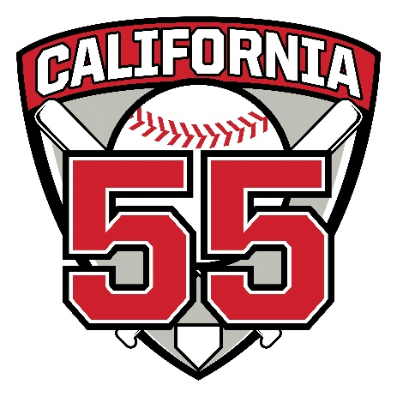
Volunteer Rookie of the Year
In 2023, the District 55 Umpire Advisory Committee approved a new recognition that would be awarded annually at our umpire appreciation lunch. The award will be given to a first-year tournament umpire as voted on by the committee.
2023 - Henry Lin (Northwood Little League)
Past Recipients of this Award are:
- 2023 Henry Lin (Northwood Little League)
- 2024 Chad Asada (Aliso Viejo Little League)

