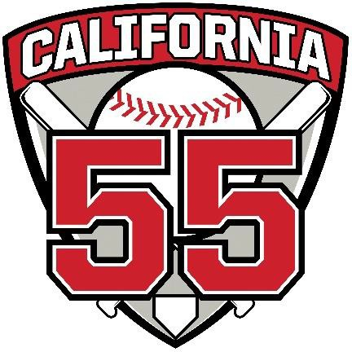**John Dowdy Award**

**John Dowdy Award** – This award is named after John Dowdy a long-time volunteer umpire in Orange County volunteering in both District 62 and District 55. John was an ardent believer in volunteerism and constantly improving your skills as an umpire. He spent hundreds of hours working games and teaching his fellow

umpires. He was a western region instructor and completed the Professional Baseball Umpire Corporation school. In 2015 he represented District 55 in Williamsport PA working the Little League World Series.

This award goes to the volunteer umpire that works the most post-season games as an umpire and is presented with a customized engraved bat at the annual umpire luncheon.

Past Recipients of this Award are:

2024 – Greg Lipford

2023 – Steve Agor

2022 – Glenn Frial

2021 – Steve Agor

2020 – None

2019 – Greg Lipford

2018 – Glenn Frial

2017 – David Spigner