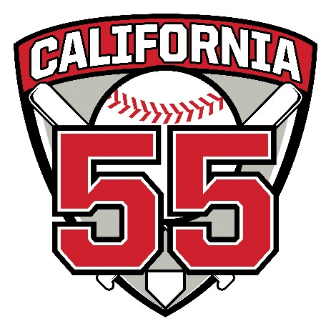
Above and Beyond Award
These umpires volunteered their time for 15 or more games during the TOC and All Star tournaments. They are presented with a customized embroidered umpire jersey at the district's umpire appreciation luncheon.
The 2024 Above & Beyond recipients are:
- Miles Acker
- Steve Agor
- Ming Chiu
- Ajay Dandekar
- Jim Frankenfield
- Glenn Frial
- Greg Lipford
- Robert Pryor
- Mitch Volman
The 2023 Above & Beyond recipients are:
- Miles Acker
- Steve Agor
- Mark Britton
- Ming Chiu
- Ajay Dandekar
- Jim Frankenfield
- Glenn Frial
- Tom Lambert
- Greg Lipford
- Raymond Palucki
- Robert Pryor
- Mitch Volman
The 2022 Above & Beyond recipients are:
- Steve Agor
- Ming Chiu
- Jim Frankenfield
- Glenn Frial
- Greg Lipford
- Raymond Palucki
The 2019 Above & Beyond recipients are:
- Miles Acker
- Steve Agor
- Ming Chiu
- Jim Frankenfield
- Glenn Frial
- Tom Lambert
- Greg Lipford
- Matt Nusenow
- Mitch Volman
The 2018 Above & Beyond recipients are:
- Glenn Frial
- Ming Chiu
- Tom Lambert
- Brian McKinstry
- Matt Nusenow
- Raymond Palucki
- Chris Watkins
- Mitch Volman
- Miles Acker
- Steve Agor
- David Spigner
- Duane Cave

